**Jahangirnagar University**

**Department of Computer Science & Engineering**



**Course Code**: CSE-402

**Course Title**: Computer Networking Laboratory

**Submitted by**:

**Name**: Md Shamim Imtiaz

**Roll No**: 47

**Date of Submission**: 19th September, 2019

**Experiment No: 04**

**Experiment Name:** VLAN configuration with Layer 3 switch and Router.

**Objective:**

In this experiment we will configure routers in between some networks to connect to further network via routing table where network and hop will be mentioned. When sending a packet this routers will recognize which hop to jump to send a packet. In this lab we will try to send the data packet through routers and set the static connections with command line prompt. Here we used three routers and generic pcs. We also added two extra Ethernet with each of the router so that we connect them each other and they will find the shortest path to send the packets.

**Description:**

We used cisco packet tracer for simulation. Several computer devices are connected through the routers and different IP addresses were assigned to them. Then a packet is sent through them to check the characteristics of routers we created a hop table to access networks that are far from the routers to pass the packets.

**Router:**

Routers are small electronic devices that join multiple computer networks together using either wired or wireless connections. In technical terms, a router is a Layer 3 network gate way device, meaning that it connects two or more networks and that the router operates at the network layer of the OSI model.

**LAN:**

A virtual LAN is any broadcast domain that is partitioned and isolated in a computer network at the data link layer. LAN is the abbreviation for local area network and in this context virtual refers to a physical object recreated and altered by additional logic.

**dot1q function:**

IEEE 802**.**1Q is a standard protocol for interconnecting multiple switches and routers and for defining VLAN topologies. Use the encapsulation **dot1q** command in sub-interface range configuration mode to apply a VLAN ID to the sub-interface.

**Simulation:**

1. **Layer 3 switch:**

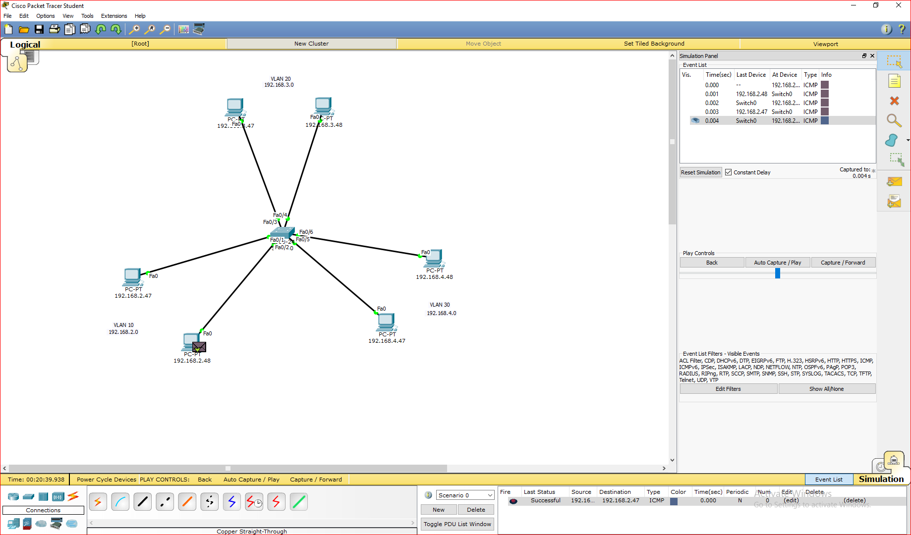

1. **Layer 3 switch and Router:**

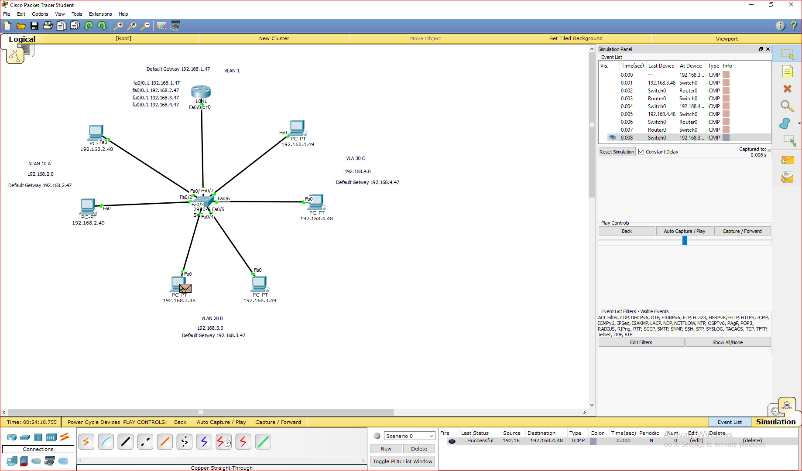

* **Configure CLI For Switch:**

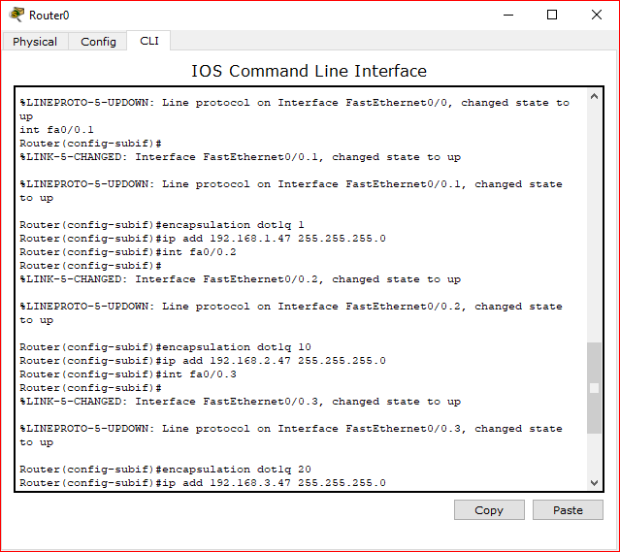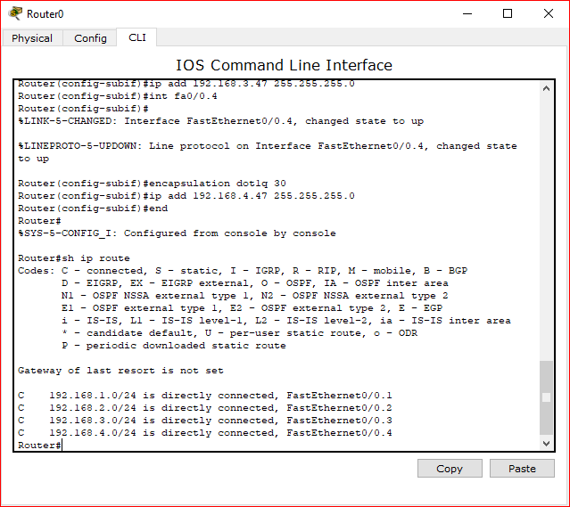

1. **Layer 4 switch and Router:**

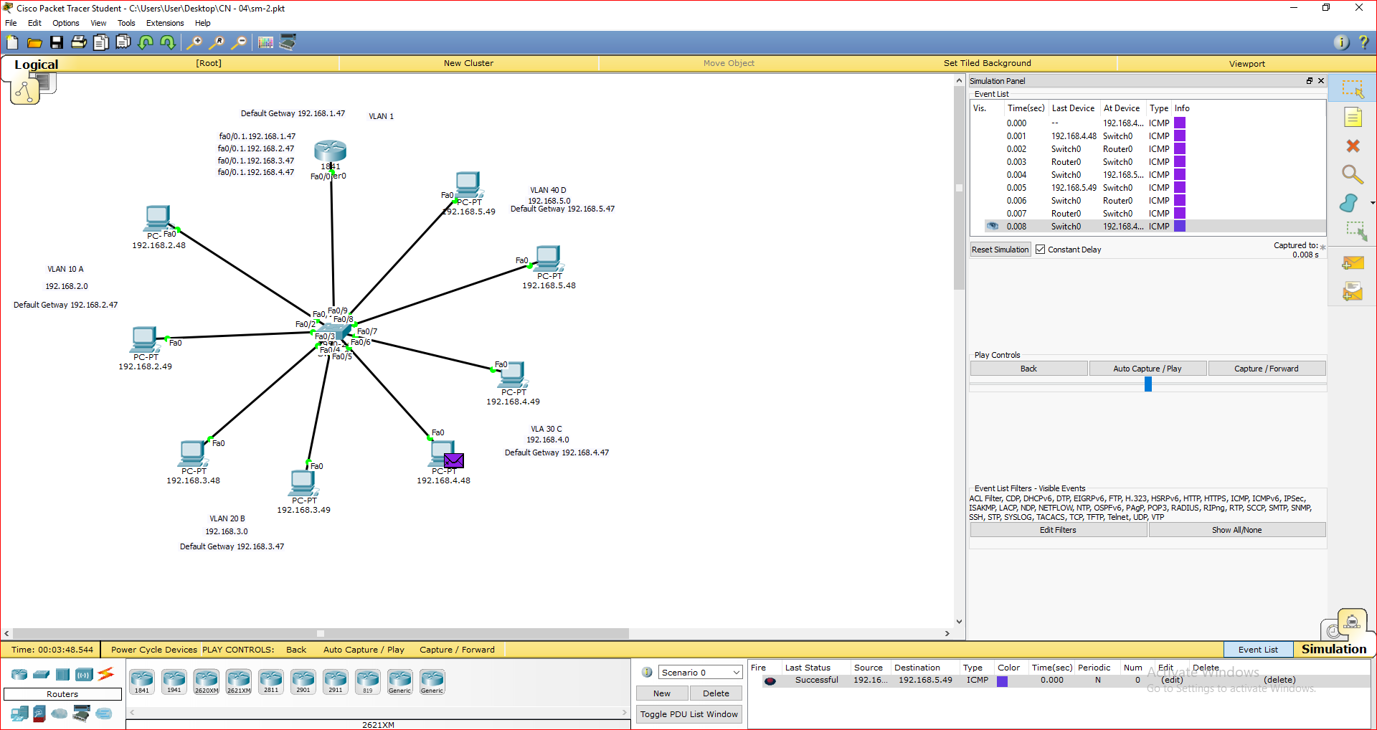

**Discussion:**

We can see that the Routers sends the packet the required path mentioned in the rout table. People tend to get benefit from a router for through a packet to a different network. A router is better for connecting different network. After using router we can easily use hub, switch, PC for any other connection and for any other communication.